The suspiciously bark-covered and knotty
Peasant Staff
(Fuste Agresti)
of
Paulus Hector Mair
Translation by Rachel Barkley
Commentary by Owen Townes
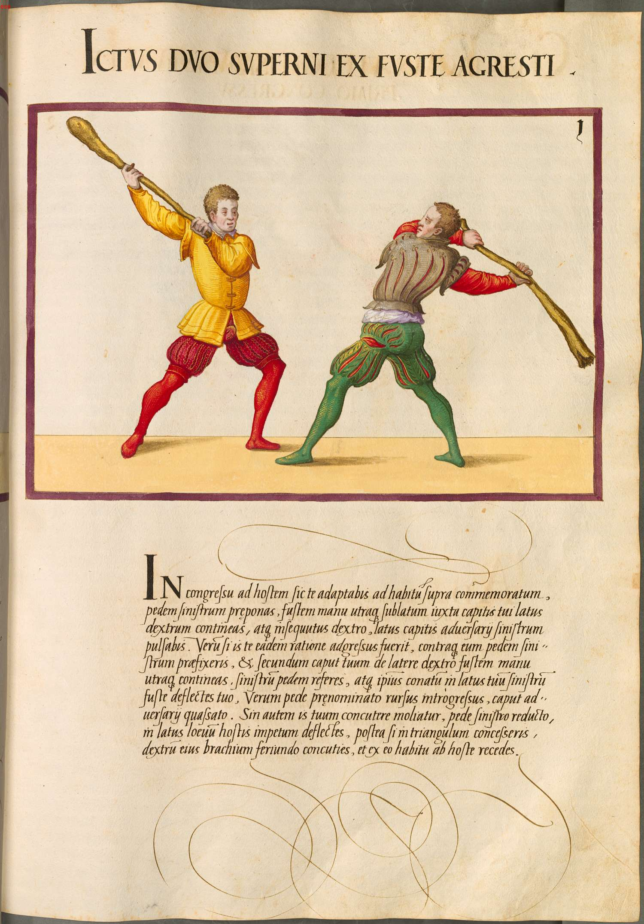
Plate 1 (pp430)
Ictus Duo Superni Ex Fuste Agresti
Two from-above blows from the staff of the countryman
A: Vom Tag, Left foot forward | P: Vom Tag, Left foot forward
In this fight thusly you will adapt yourself against the enemy to the commemorated position above. You should place forward the left foot, you should hold the club raised in both hands next to the right side of your head, and moving forward with the right, you will strike the left side of the enemy’s head. | A: Onside Oberhau, stepping in with Right foot
If he has attacked you by the same reasoning and you will have fixed forward the left foot against him, and should you hold the club with both hands behind your head from the right side, you should draw back the left foot and you should deflect his blow on your left side with your club. Then you pursuing again with aforenamed foot, strike the adversary’s head. | P: Draw Left foot back, deflect to Left side. Step in with Left foot and offside Oberhau
If however he attempts to shatter your head, then with the left foot having been drawn back, you should deflect the enemy’s attack on the left side. Afterwards, if you will have stepped in a triangle you should bang his right arm by striking and from this position you should retreat from the enemy. | A: Draw Left foot back, deflect to Left side. Step in a triangle and strike Right arm

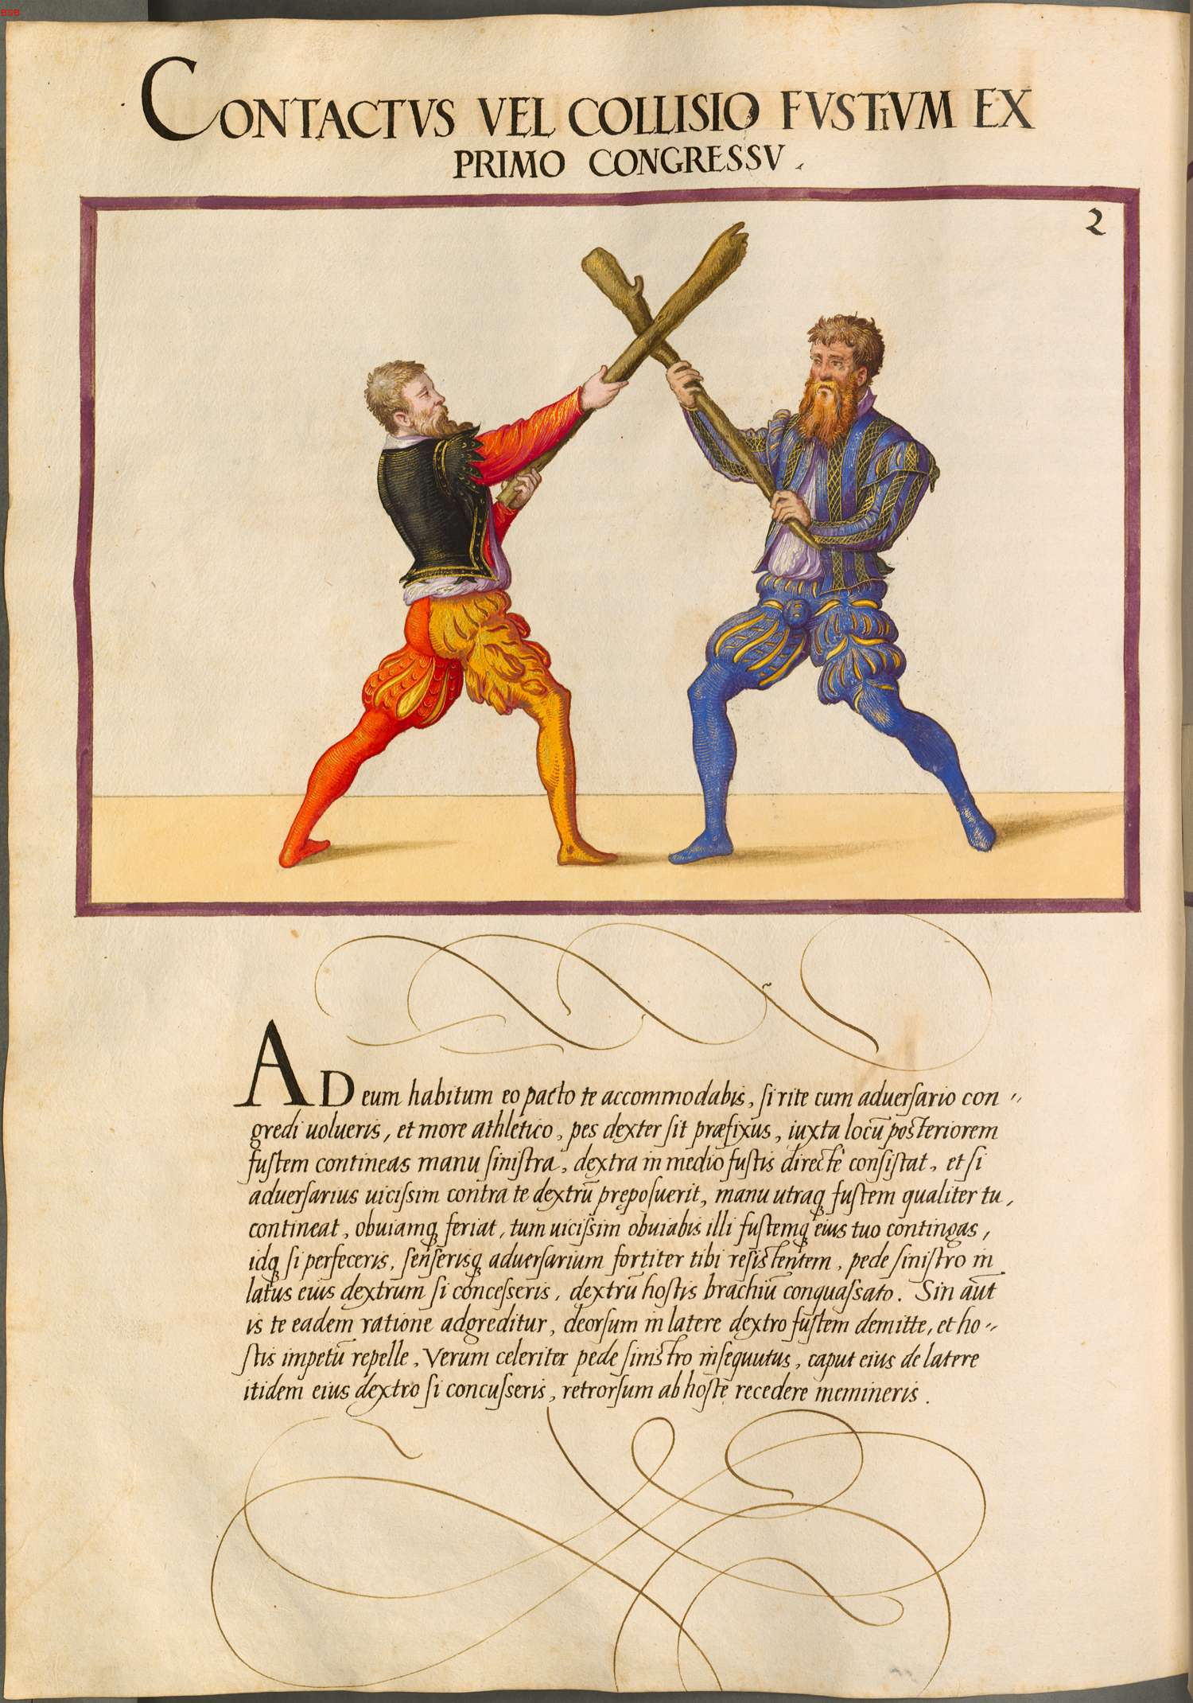
Plate 2 (pp431)
Contactus vel Collisio Fustium Ex Primo Congressu
Contact or Collision of the staffs from the first fight
A: Right foot forward, medium grip, Vom Tag or Plow | P: Right foot forward, medium grip, Vom Tag or Plow
You will accommodate yourself in this manner to this position if rightly you will have wished to engage with the enemy. In the athletic custom, the right foot should have been fixed forward, you should seize the club next to the posterior end with the left hand, the right hand directly should stand in the middle of the club, and if in turn the adversary will have positioned forward his right foot against you, should he hold the club with both hands just as you and in order to make contact he should strike, then in turn you will meet him and you should touch his club with your own. If you will have completed this and you will have felt the enemy resisting strongly to you, if you will have moved with the left foot against his right side, strike the right arm of the enemy. | A: Oberhau Right  P: Oberhau Right to block  If A is “Strong in the Bind”, yield, step in with Left foot, and strike A’s Right arm
If however he attacks by the same reckoning, send the club on the right side downward, and repel the enemy’s attack. Thence you following quickly with the left foot, if you will have struck the right side of his head again, you should remember to retreat back from the enemy. | A: Block with Right-side Scales  Yield, step in with Left foot, strike P’s head

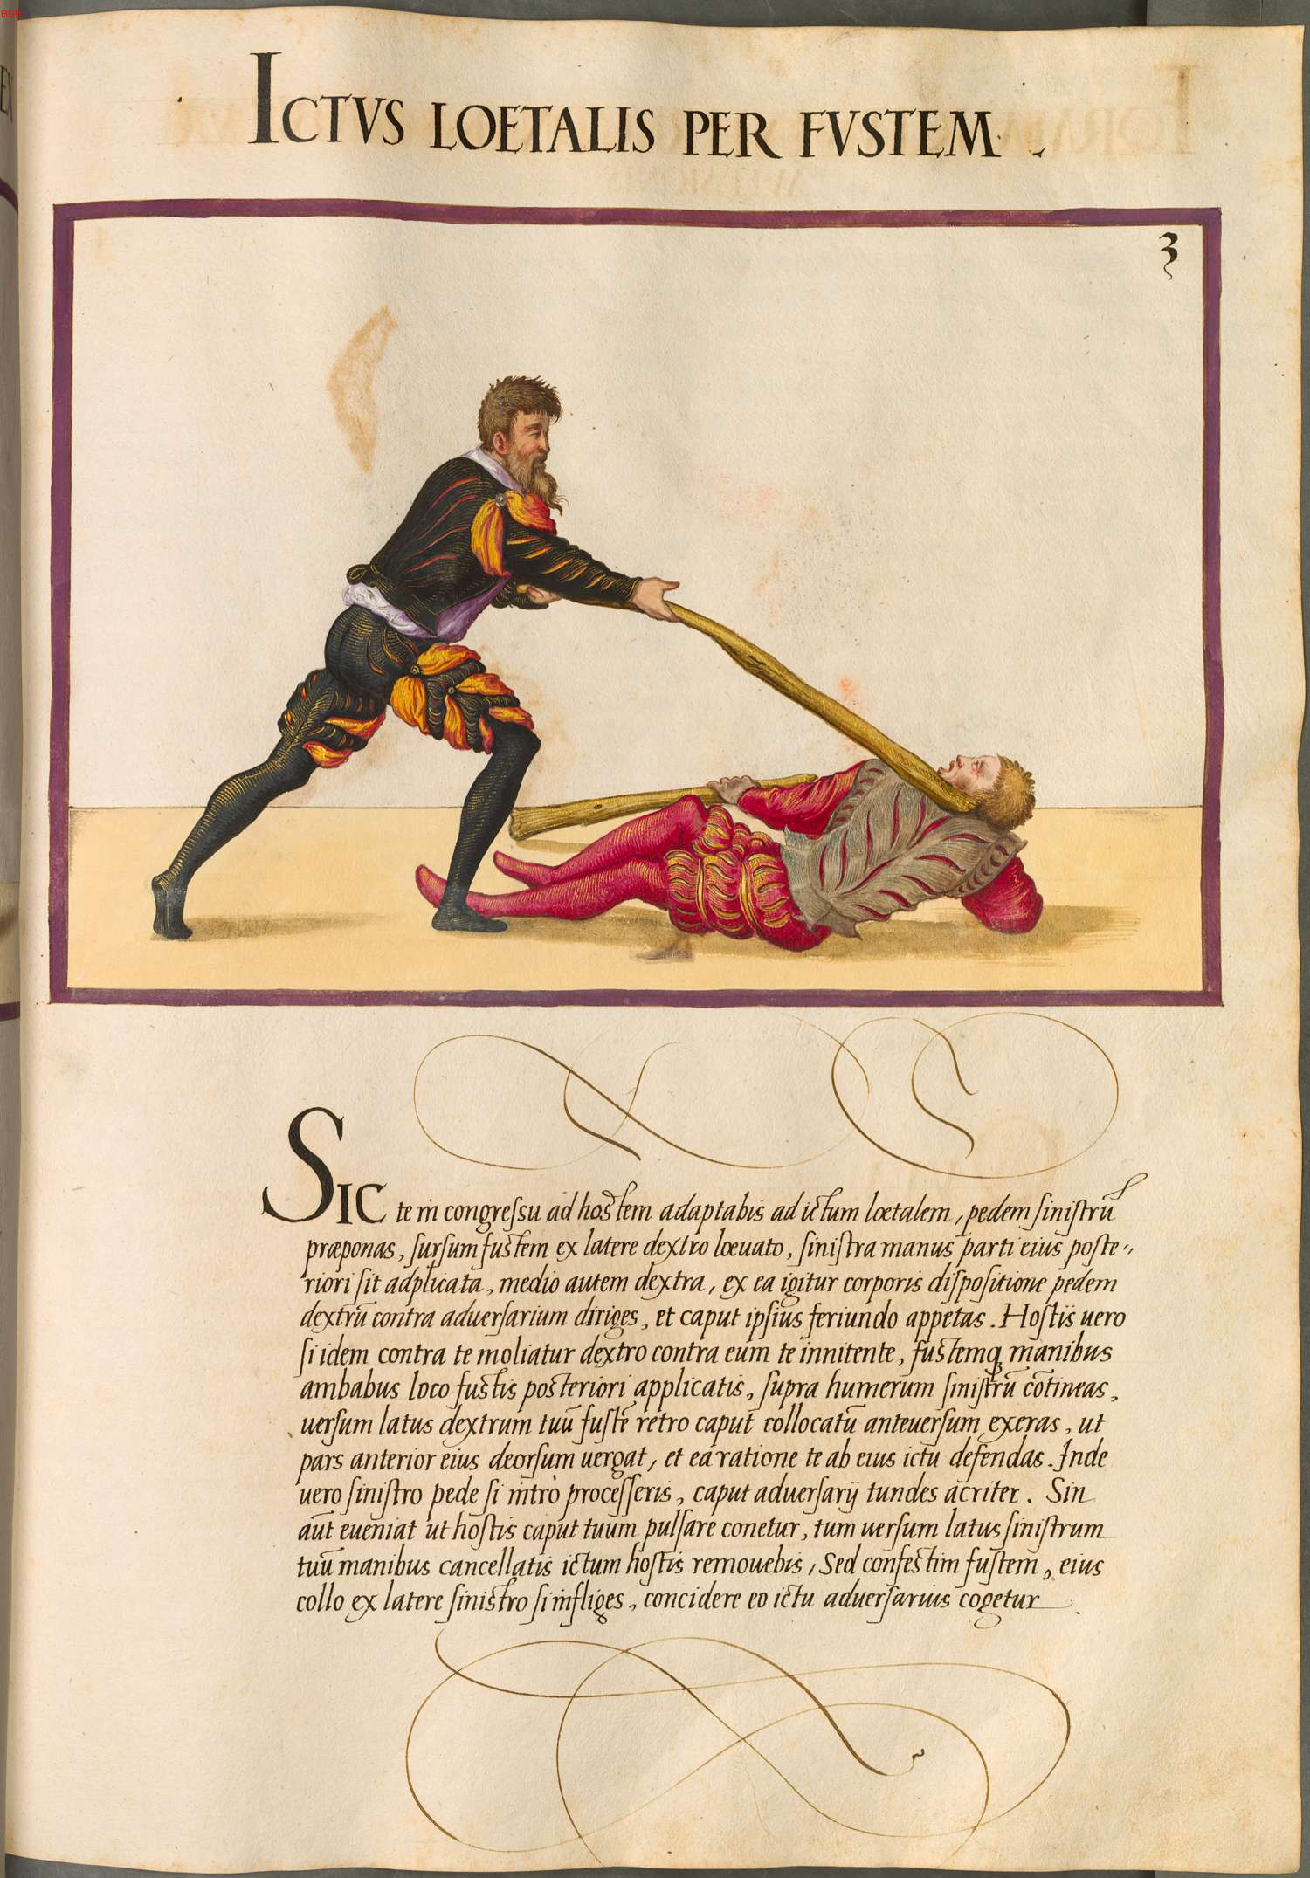

Plate 3 (pp432)
Ictus loetalis per fustem
Lethal blow on behalf of the staff
A: Left foot forward, Vom Tag on Right side, medium grip | P: Long grip, Left side Vom Tag, Right foot forward
You will adapt yourself in the fight against the enemy against the lethal blow. You will place forward the left foot, raise upward the staff from the right side, the left hand should be placed on the lower end of the staff, the right hand however in the middle, and from such an arrangement of the body you will direct the right foot against the adversary, and you will seek his head by striking. | A: Oberhau on Right, step in with Right foot
If the enemy should attempt to do the same against you, you supporting yourself against him, and both hands are applied to the lower end of the staff, you should hold the staff above the left shoulder, you should thrust forward the anticipated collected staff from behind the head, the staff having been turned toward your right side, so that upper part of his staff moves downward, and by this rationale you should be able to defend yourself from his blow. Then if you have proceeded on the inside with the left foot, you should sharply thump the head of your adversary. | P: Thrust high Left side to block, yield to a Right-side Scales  Step in with Left and strike with a Left-side Oberhau
But if however it should come about such that your enemy attempts to strike your head, then you will remove the blow of the enemy by hands having made like a lattice having turned your left side. But suddenly if you should strike the staff against his neck from the left side, the enemy should be forced to beat severely against this strike. | A: Rotate to Right, transition to Left-side (ish) Scales  Onside(?) Oberhau
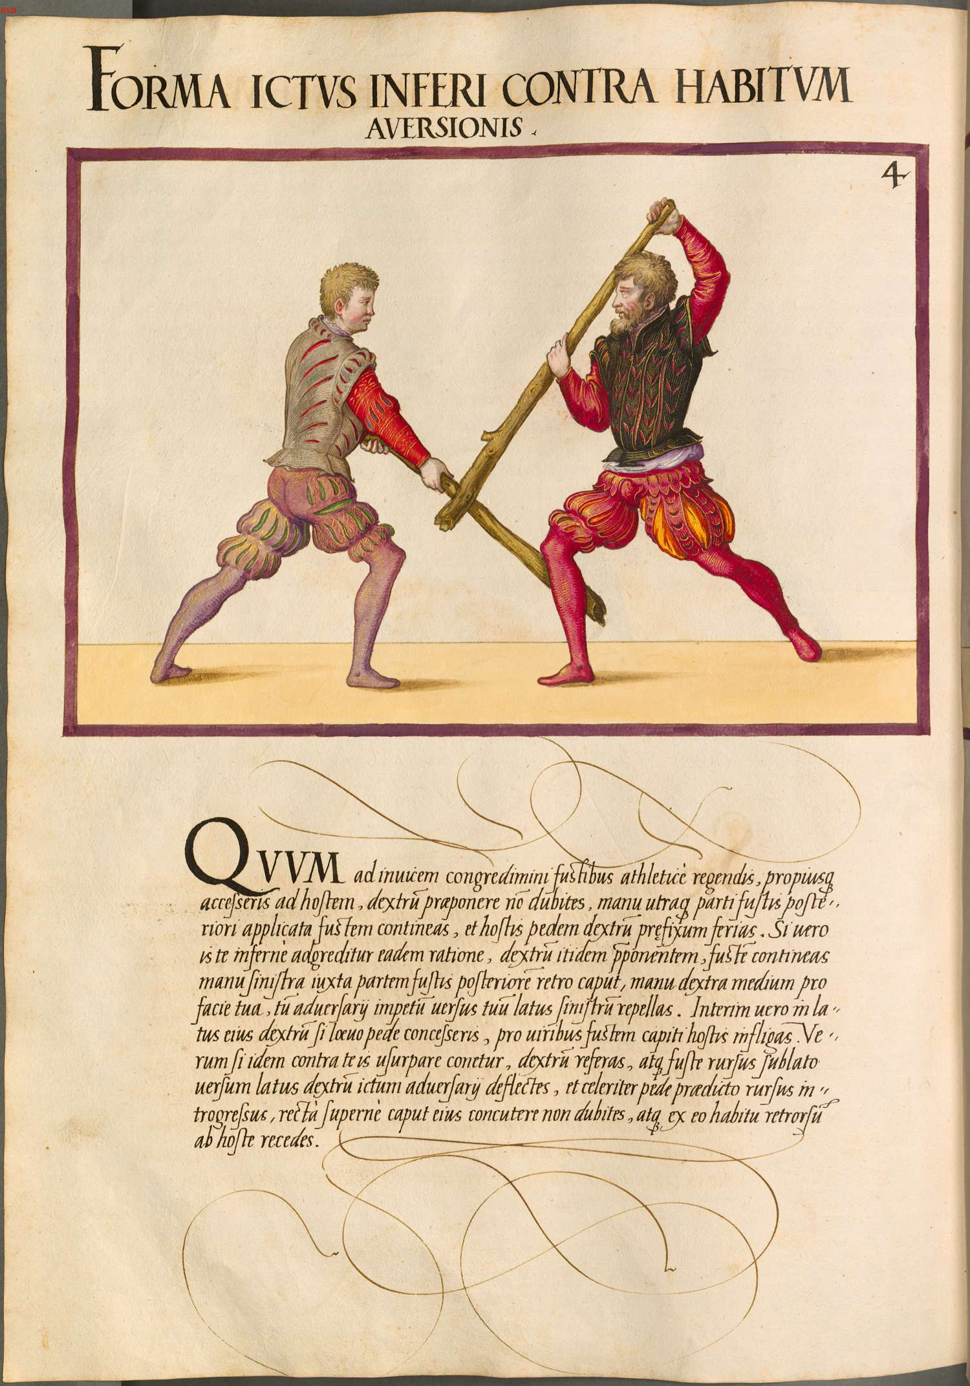
Plate 4 (pp433)
Forma ictus inferni contra habitum aversionis
Form of a from-below blow against the position of aversion/defense
A: At close measure, Right foot forward, hanging guard. Long grip | P: At close measure, Right foot forward, hanging guard. Med Grip
You should by turns accost with the staffs rightly like an athlete, and you should step closer toward the enemy you should not doubt to put forward the right foot, you should hold the staff with both hands applied to the lower end of the staff, and you should strike the fixed-forward right foot of the enemy. | A: Strike forward Right leg (sweep?)
If however he should by the same reasoning attack you from below, you at the same time putting forward the right foot, you should hold the staff with the left hand next to the lower part of the staff behind the head, the right hand in the middle before your face, then you should repel the blow of the enemy, you turning your left side. Meanwhile if you have on his right side stepped forward with the left foot, you should strike with force the staff on the head of the enemy. | P: Deflect to Right side, turning to the Right  Step forward with Left foot, offside Oberhau
If he attempts to attack against you in the same manner, you should pull back the right foot, and you should deflect the blow of the enemy on the right side with the raised backwards staff, and quickly you should pursue in again with the aforementioned foot, you should not waver to strike rightly from above the head of your enemy, and from this position you should retreat from you enemy. | A: Step back with Right, deflect in Right-side scales,  Step in with Right and onside Oberhau

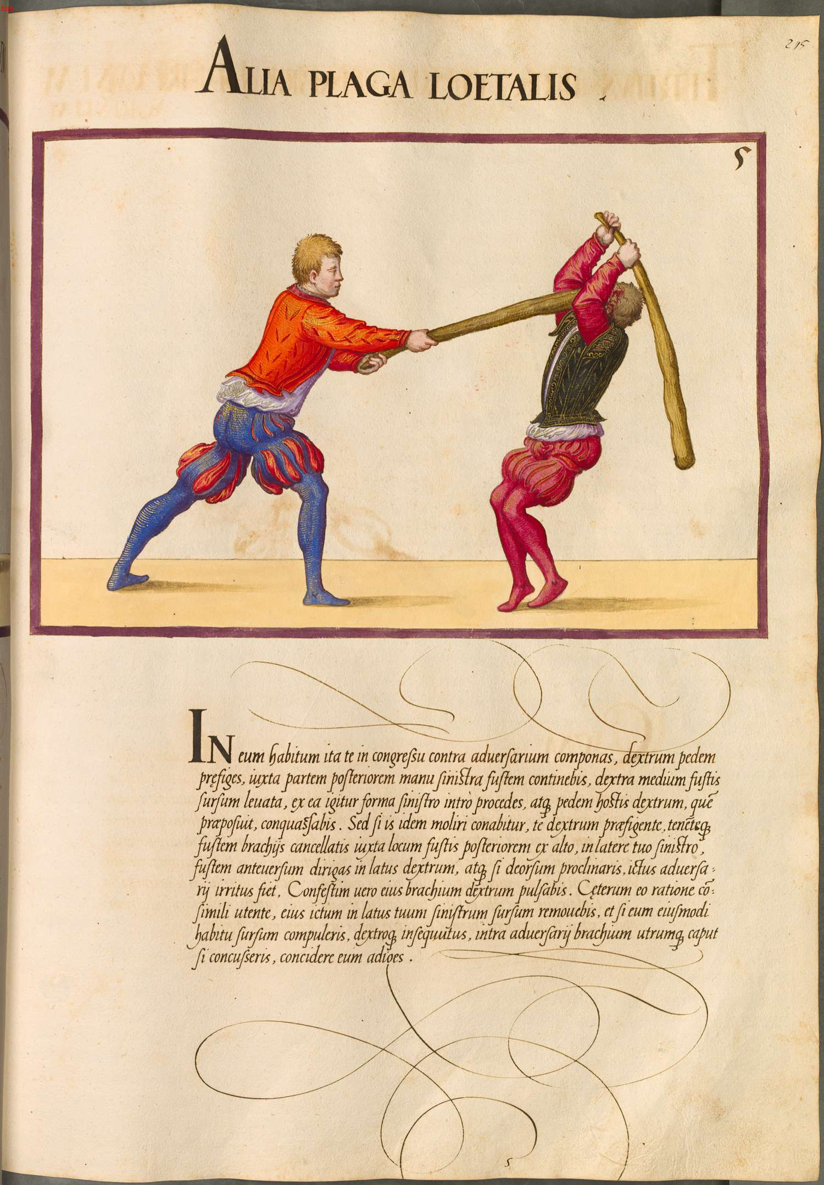
Plate 5 (pp434)
Alia plaga loetalis
Another lethal strike
A: Right foot forward, high guard | P: Right foot forward, high guard
In this manner you should position yourself against the adversary in the fight, you should fix forward the right foot, you will hold the staff with the left hand next to the lower end, the right hand raised above in the middle of the staff, and from this position you should proceed to the inside on the left, and you will strike the enemy’s right foot which he has placed forward. | A: Step in with Left foot,  Low (sweep) to Patiente’s Right foot
But if he will attempt the same against you fixing forward your right foot and holding the staff with your arms making a lattice next to the posterior end of the staff from above, on your left side, you should direct the extended-forward staff on the right side and if you will have bent forward from above, the blow of the adversary becomes useless. Immediately you will strike at his right arm. | P: Deflect into Lattice-Scales on Right  Leaning in, strike Agente’s Right arm
When he has used this by the same reasoning, you will have forced from above that blow of his on the left side, and you seeking with your right foot, if you will have struck on the inside the head of the adversary with both arms, you should make to ruin him. | A: Deflect upward  Step in with Right foot and BASH THE FUCK OUT OF HIS FACE

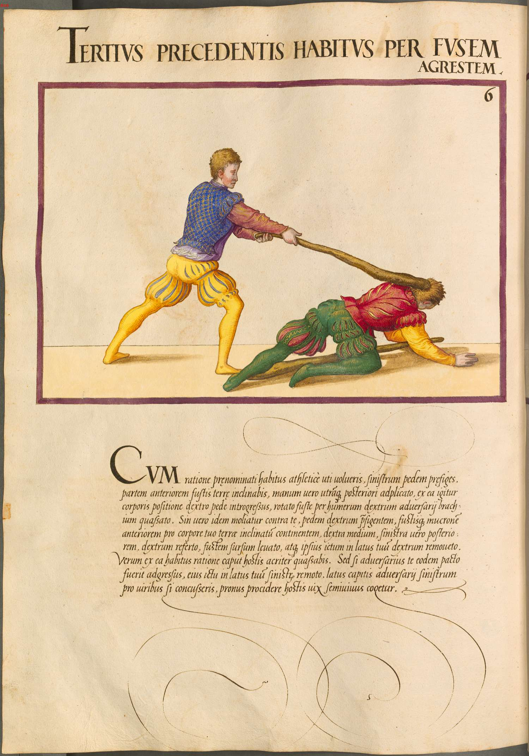
Plate 6 (pp435)
Tertius precedentis habitus per fustem agrestem
A third moving-forward position before the rustic staff
A: Left foot forward, long grip, hanging guard | P: Right foot forward, med grip, hanging guard
You should wish to use the aforementioned position by the reasoning of an athlete. You should fix forward the left foot, you will incline the upper part of the staff toward the ground, both hands applied to the lower end, and from this position of the body you following with the right foot, strike the right arm of the adversary with the well-turned staff through the shoulder. | A: Step in with Right foot, strike Patiente’s right arm
But if he should attempt the same against you fixing forward the right foot and holding the upper end of the staff inclined toward the earth before your person, the right hand in the middle and the left hand on the lower end, draw back the right foot, lift the staff up overhead, and remove his own blow on your right side. Thence from this position by this rationale you will strike sharply the head of your enemy. | P: Withdraw Right foot,  Deflect to Right-side Scales  Onside Oberhau
But if the adversary has attacked you from the same position, remove his attack from your left side and if you will have struck the left side of the adversary’s head through this attack, the half-alive enemy will soon be driven to fall down. | A: Deflect to Left side  Strike enemy’s head

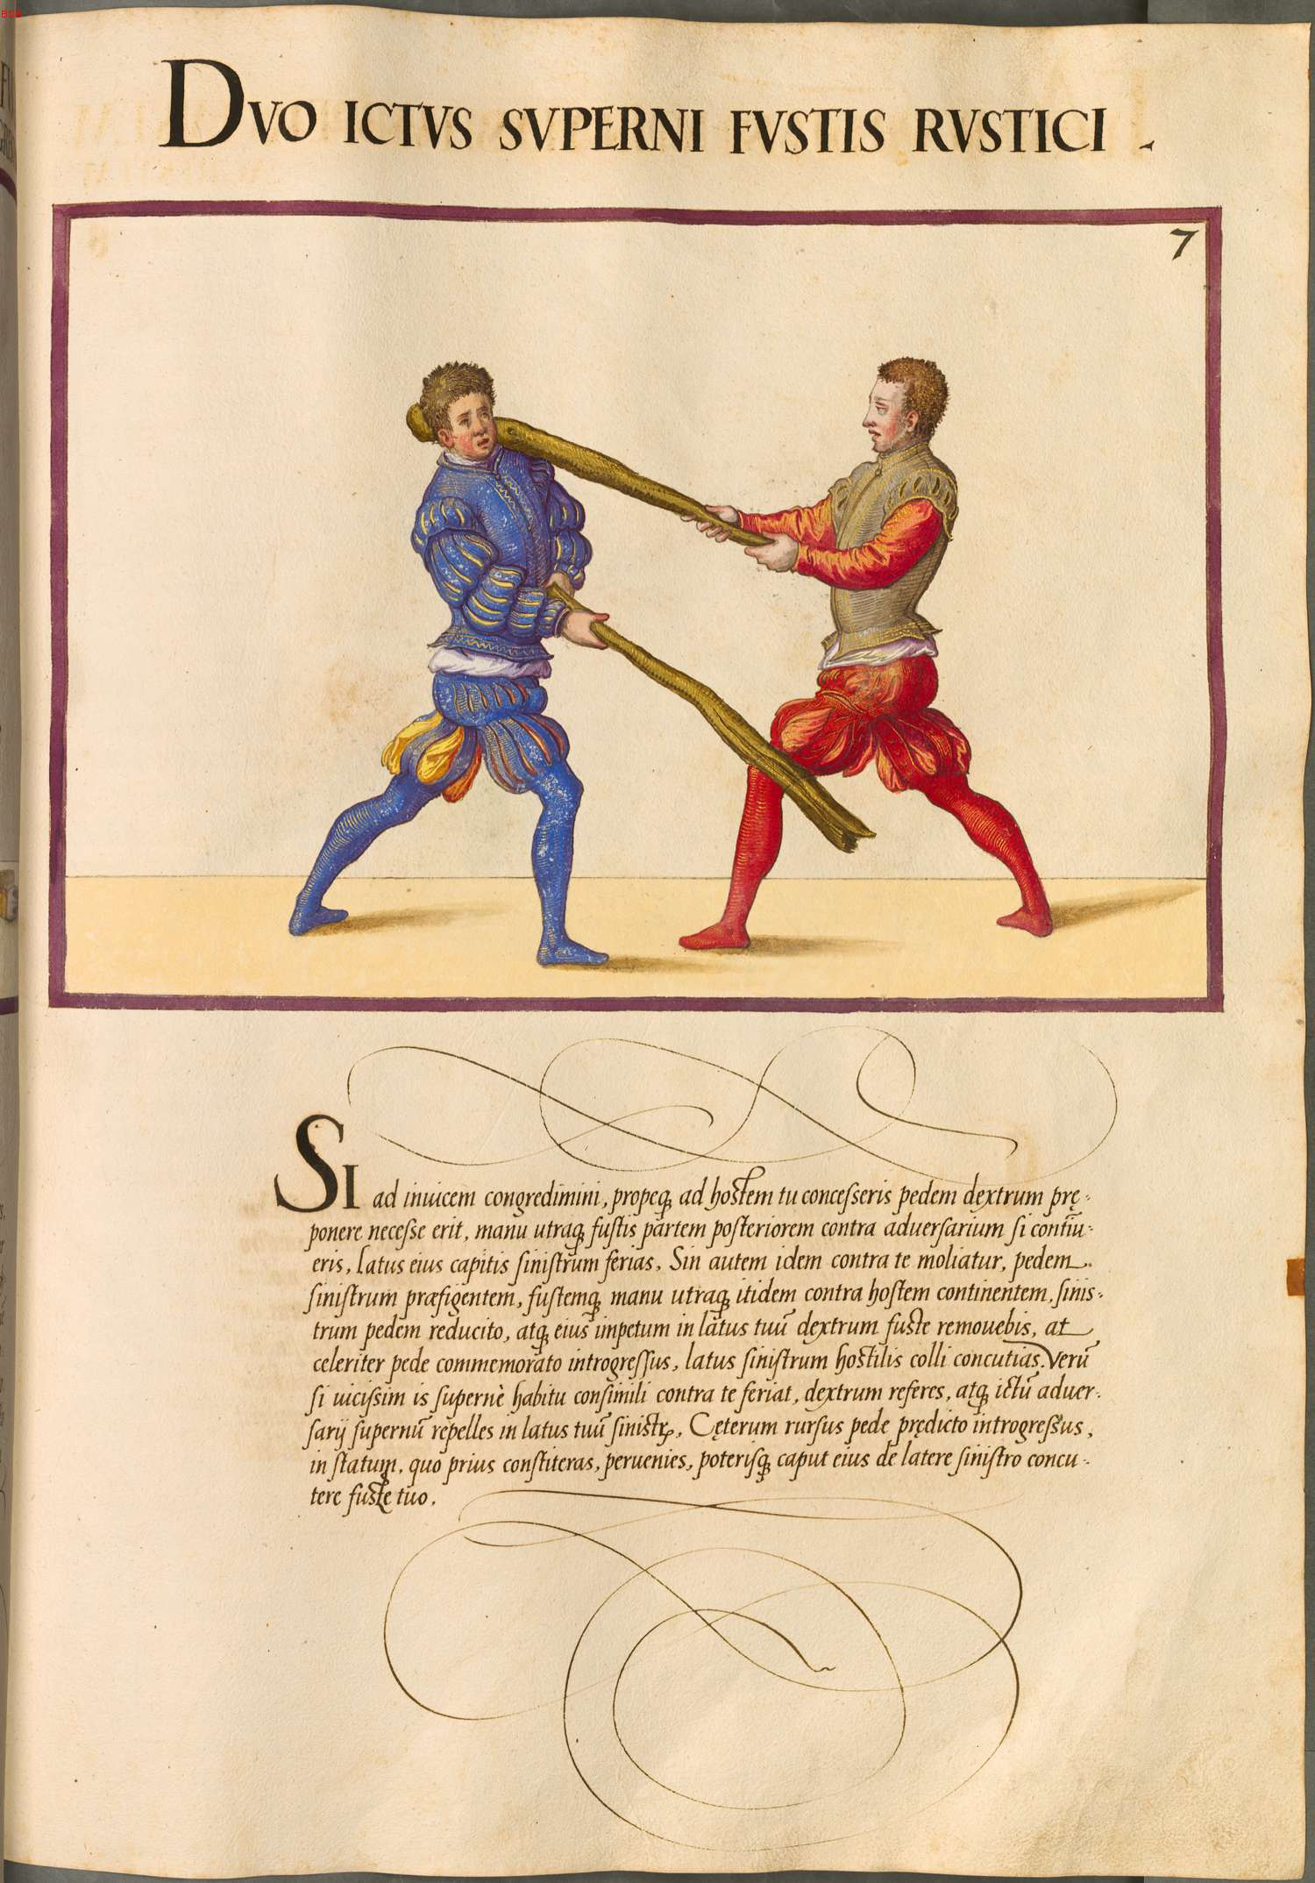
Plate 7 (pp436)
Duo ictus superni fustis rustici
Two from-above blows of the rustic staff
A: Close measure, Long grip in Crown guard, Right foot forward | P: Close measure, long grip Crown guard, Left foot forward
If you both proceeded in turn and you have ceded closer toward the enemy it will be necessary to put forward the right foot, it will be necessary to put forward both hands on the lower end against the enemy if you should hold the staff, you should strike the left side of his head. | A: Onside Oberhau
If however he attempts the same against you, you fixing forward the left foot, and holding the staff against the enemy with both hands at the same time, you will remove the staff on your right side, and you seeking forward quickly with a remembered foot, you should strike the neck of the enemy on the left side. | P: Deflect to Right side,  Step in with Right foot,  Onside Oberhau
If he in turn should strike against you in a similar position from above, you should draw back the right foot, and you should repel the above blow of the enemy on your left side. Then pursuing again with aforementioned foot, in this place, from which you should have stood closer, you should come up and you should be able to strike his head on the left side with your staff. | A: Withdraw Right foot,  Block on Left,  Step in w/ R,  Onside Oberhau

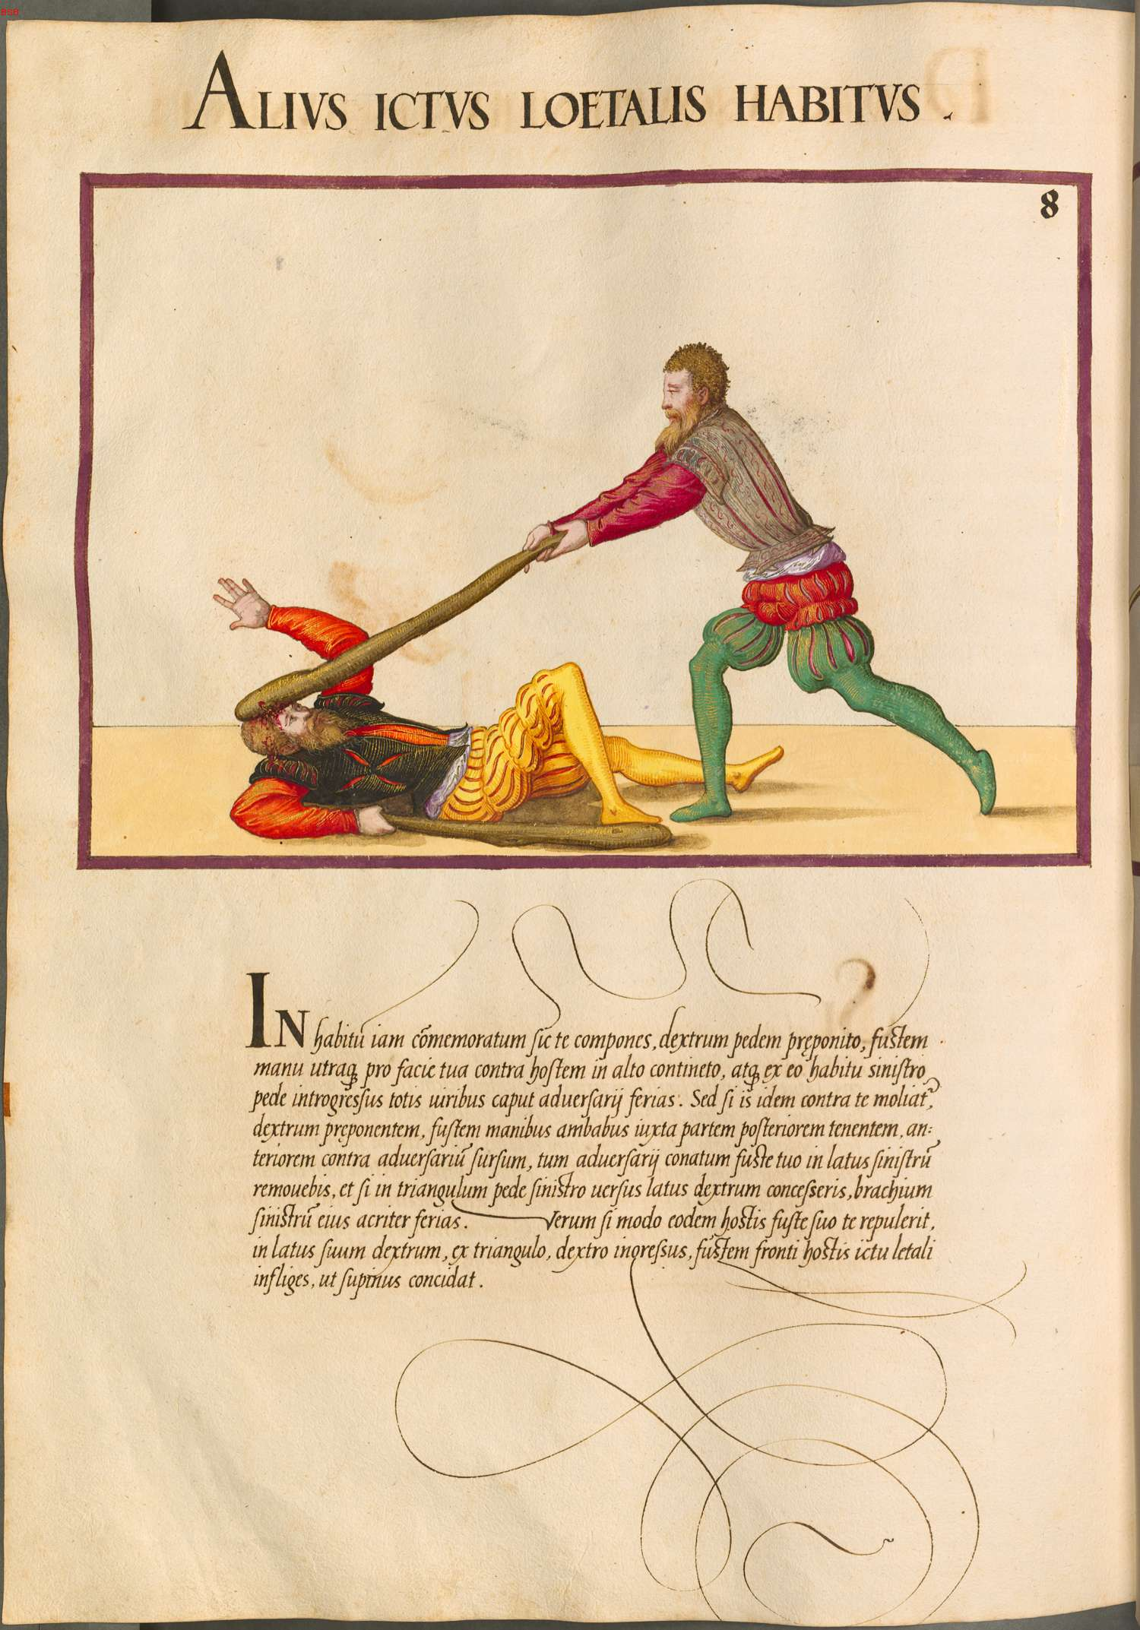
Plate 8 (pp437)
Alius ictus loetalis habitus
Another position of a lethal blow
A: Right foot forward, Crown | P: Right foot forward, Crown
In the position now commemorated you should arrange yourself, place forward the right foot, hold the staff high against the enemy with both hands before your face, and from this position pursuing forward with the left foot you should strike with total force the head of your adversary. | A: Step in with Left,  Vertical Oberhau
But if he attempts the same against you placing forward the right foot, holding the staff with both hands next to the lower end, the forward end raised up against the enemy, then you will remove the adversary’s attempt on the left side with your staff, and if you will have moved in a triangle with the left foot turning the right side, you should strike sharply his left arm. | P: Deflect to Left,  Triangle step to Right,  Strike Left arm
If the enemy has repelled you by the same manner with his own staff, on his own right side, from the triangle, you pursuing inward with the right foot, you should strike the staff on the front of the enemy with a lethal blow so that he falls down face up. | A: Triangle step to Left  Strike his face

GLOSSARY

Crown Guard: Staff held vertically in front of face

Hanging Guard: A guard formed with the left hand above the head, the right hand extended out straight from the shoulder, the staff angled downward at about 45 degrees and towards the enemy.

Oberhau: A descending strike from above

Offside: A blow delivered from Agente’s left side

Onside: A blow delivered from Agente’s right side, like swinging a baseball bat

Scales: A completely defensive hanging guard, formed with the staff vertical (head towards the ground) next to the right of left side as indicated

Triangle Step: A full step (both feet move) to the right or left and forward, rotating around the enemy

Vom Tag: A guard formed with the right hand at shoulder level and close to either the right or left shoulder, the staff vertical and pointing upward

Looks like a fancy way of saying “in the pretty picture above the pretty words.”
The “offside” could be an error, depending on some of the sidedness of the above actions
Latin says pede sinistro reducto. You are right that this is probably not the object of concutere, so another way to take it is as phrase describing the enemy. So, the adversarius will have HIS left foot having been drawn back.
Play starts after the bind is formed, so P’s actions are the first described
Words used are more athletico, so that’s a literal translation. I think it’s the same sort of “athletic custom” that we similarly saw in the Peasant Flail section.
Word is contingere which can also mean “reach”, “take hold of”, “seize.” It’s clearly not “block” because Mair would use avertere
Latin says pede sinistro in latus eius dextrum. It does not specify any further directionality.
Latin says ad hostem adapabis ad ictum loetalem. That’s a very literal translation, and you may even have to look at something as absurd as the word order. It could be taken as either the lethal blow that your enemy is about to deliver, or the lethal blow that you will deliver. Based on the context, it might be the latter. I’ve checked the Perseus Project’s dictionaries, and my guess is a translation along the line of “for a lethal blow.” So, position yourself against the enemy for a lethal blow. That may help only slightly.
I know, sound silly. Latin says tuum fustem retro caput collecatum anteversum. I can’t seem to find a better definition of collecatum but it’s probably an adjective formed off of a verb part. If Mair had a fit of poetic license, this might be some kind of interlocking order. You could say “your anticipated staff from behind your collected head. It’s tricky because all of the words used are neuter.
The lattice reference is that you should be making an “X” with your arms.
Sursum is “from below upwards”
Word is insequtuus which I’ve translated a few different ways. You could take it as “attacking”
The word used is aliges concidere and could not find a decent translation at all for aligo so I had to wing it.
Per the translator, this interpretation is most reflective of the tense and syntax used in the Latin.
Rotate your staff over the top of his to strike an off-side on his blow. The step in with the Right Foot likely manifests a feint to bring his guard over to his left.
This passage causes some angst on the part of the translator, as “Fixing the ___ foot” has usually been understood to mean that foot will not move during this action. However, the Right foot is immediately withdrawn here.
I love Mair.
This might be in either Scales or Vom Tag. The lack of specificity as to the following strike makes it difficult to be sure, and either works.
A transition to a hanging guard and continuing deflection to a right-side scales would seem to be in order here to deflect the opponent’s blow and set up the strike to the face

